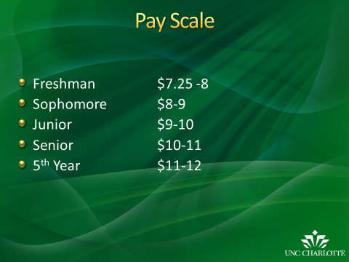

Pay should be commensurate with education and experience. The scale will cover most, if not all student jobs on campus. Pay increases should be a reward for good performance. The idea is to bring students in when they are freshman and each year as they perform well and come back with more experience, they are rewarded with pay rate increases. SEO can approve up to $1 per year.
When submitting budget requests departments should ask for a pay rate that falls within the ranges.
STW and FWS $12 per hour or under
Grads on STW appointment $15 per hour or under

